
Year 11 Essentials

Mini Test 1.2

Order of Operations and Percentages
Name:________________

 | Total Marks: /16
Resources allowed: Calculator | Total Time: 16 mins | Weighting: 1%

- [5 marks]
Scoring in basketball depends on where a player shoots from. A successful shot from inside the three-point line scores two points; from outside the three-point line, it scores three points. Each successful free shot from the foul line scores one point.

The number of successful shots for two teams during a match is shown in the table

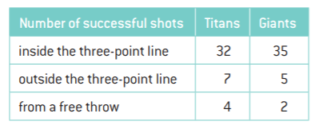

- Complete these statements to show the numbers and operations needed to calculate the total points scored by each team.

Points scored by Titans = ___× 2 +___ × 3 +___ × 1

Points scored by Giants = ___ ×___ +___ ×___ + ___×___

- Calculate the number of points each team scored

- Which team won and by how much?

- [2 marks]
Write each percentage as a decimal

a) | 23% | b) | 16.52%

- [2 marks]
Write each decimal as a percentage

a) | 0.47 | b) | 0.0003

- [1 mark]
Write $\frac{17}{20}$ as a percentage

- [1 mark]
Write 24 out of 150 as a percentage

- [1 mark]
Calculate 37% of $2400

- [4 marks]
Brock is a farmer who intends on increasing the amount of land he owns. He currently has 250 hectares. He would like 20% more land.

- Calculate how much land Brock would have if he increased his land by 20%

- Brock was able to buy 40 hectares of land. Was this more or less than the amount that he wanted to get?

- Does Brock need to purchase any more hectares to get the total amount of land he wanted? If so how much.

~End of Test~

